| **date** | **type** | **description** | **city** |
| --- | --- | --- | --- |
| 20180115 | murder | Security footage shows that there were 2 witnesses. The first witness lives at the last house on "Northwestern Dr". The second witness, named Annabel, lives somewhere on "Franklin Ave". | SQL City |

SELECT * FROM crime_scene_report

WHERE date = 20180115 AND type LIKE 'Murder' AND city = 'SQL City'

| **id** | **name** | **license_id** | **address_number** | **address_street_name** | **ssn** |
| --- | --- | --- | --- | --- | --- |
| 14887 | Morty Schapiro | 118009 | 4919 | Northwestern Dr | 111564949 |

| **id** | **name** | **license_id** | **address_number** | **address_street_name** | **ssn** |
| --- | --- | --- | --- | --- | --- |
| 16371 | Annabel Miller | 490173 | 103 | Franklin Ave | 318771143 |

SELECT * FROM person

WHERE name LIKE '%Annabel%' AND address_street_name LIKE 'Franklin Ave'

person_id transcript

14887 I heard a gunshot and then saw a man run out. He had a "Get Fit Now Gym" bag. The membership number on the bag started with "48Z". Only gold members have those bags. The man got into a car with a plate that included "H42W".

16371 I saw the murder happen, and I recognized the killer from my gym when I was working out last week on January the 9th.

SELECT * FROM interview

WHERE person_id IN ('16371', '14887')

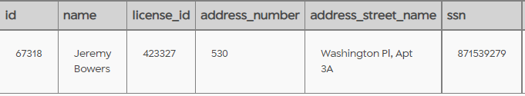

SELECT * FROM person as p

JOIN drivers_license as d ON (p.license_id=d.id)

WHERE p.id IN ('28819', '67318')

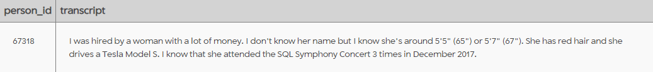

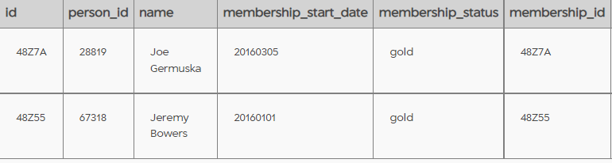

SELECT * FROM get_fit_now_member as gm

JOIN get_fit_now_check_in as gc ON (gm.id = gc.membership_id)

WHERE gm.membership_status LIKE 'gold' AND gc.check_in_date ='20180109'

AND membership_id LIKE '%48Z%'

SELECT * FROM drivers_license

WHERE hair_color LIKE 'Red' and car_make LIKE 'Tesla' AND car_model LIKE 'Model S'

AND height<68 AND height>64

| **id** | **age** | **height** | **eye_color** | **hair_color** | **gender** | **plate_number** | **car_make** | **car_model** |
| --- | --- | --- | --- | --- | --- | --- | --- | --- |
| 202298 | 68 | 66 | green | red | female | 500123 | Tesla | Model S |
| 291182 | 65 | 66 | blue | red | female | 08CM64 | Tesla | Model S |
| 918773 | 48 | 65 | black | red | female | 917UU3 | Tesla | Model S |

SELECT * FROM facebook_event_checkin as f

JOIN person as p ON(f.person_id = p.id)

JOIN drivers_license as d ON(p.license_id=d.id)

WHERE d.id IN(SELECT id FROM drivers_license WHERE hair_color LIKE 'Red' and car_make LIKE 'Tesla' AND car_model LIKE 'Model S'

AND height<68 AND height>64 AND)